**Dissecting FinTech Innovation:**

**A Case Study on PhonePe Growth, Database Design, and Market Strategies**

|  |  |
| --- | --- |
|  | **Abstract**  This study explores PhonePe’s role in the FinTech industry, analyzing its core features, database structure, and revenue growth strategies. It examines real-world problems solved by PhonePe, its impact on digital payments, and data-driven business decisions. Through guesstimates and scenario-based analysis, the study highlights key challenges and opportunities in the sector. Furthermore, the study focuses on identifying potential avenues to increase PhonePe’s profit by 25%, considering factors such as market expansion, product diversification, operational efficiency, and enhanced monetization strategies. By leveraging data-driven insights and technological advancements, PhonePe can optimize its financial performance and sustain long-term growth in the competitive FinTech landscape.  **Sanjay Dalawai** |
|  |  |
|  |  |

**Contents**

**• Popularity, Impact of PhonePe (Pages 3-5)**

**• Relevance of PhonePe in India's Digital Economy (Pages 6-10)**

**• Analysing PhonePe's Current Status (Pages 12-18)**

**• Current Challenges and Solutions for PhonePe (Pages 19-20)**

**• Strategies to Monetize & Scale Pincode App Effectively (Pages 21-22)**

**• Grow in WealthTech – Stock Trading & Investments (Pages 23-24)**

**• How PhonePe Can Increase Profits from Indus Appstore (Pages 25-27)**

**• Transaction-Latency Issue (Pages 28-29)**

**• PhonePe’s IPO Strategy: Ensuring Profitability & Market Leadership Before Going Public (Pages 35-39)**

**• Database Management & Schema Design (Pages 40-49)**

**• PhonePe Revenue Sources (Pages 49-52)**

**• Customer Acquisition & Retention Analysis for PhonePe (Pages 53-57)**

**• Guesstimates (Pages 58-64)**

**• Performing Cohort Analysis for Monthly Retention Rate (Pages 65-73)**

**• A/B Testing Loan Approval Notifications (Pages 74-79**

**Case Studies & Guesstimates for FinTech Industries**

The FinTech industry has emerged as a dynamic and transformative force in the financial sector, integrating technology with financial services to enhance efficiency, accessibility, and customer experience. In today's era, FinTech is crucial for democratizing financial services, and providing underserved populations with access to banking, credit, and investment opportunities. It fosters innovation through digital payment systems, peer-to-peer lending platforms, and blockchain technology, revolutionizing traditional banking practices.

Data scientists play a pivotal role in the growth of FinTech by leveraging advanced analytics and machine learning to improve risk assessment, fraud detection, and personalized financial services. Their expertise enables FinTech companies to analyze vast amounts of financial data, uncovering insights that drive strategic decision-making, optimize operations, and enhance customer satisfaction. By harnessing the power of data, data scientists help FinTech firms stay competitive, innovate continuously, and contribute to a more inclusive and efficient financial ecosystem.

**PART – I**

**Product Dissection**

**Platform Selection  -  PhonePe**

**Question:**

Choose a leading platform from a domain related to the FinTech industry. Justify your selection by discussing the platform's popularity, impact, and relevance in its industry.

**Popularity**

PhonePe has emerged as **India’s leading digital payments platform**, dominating the UPI ecosystem with over **585 million registered users** and **40 million registered merchants**. Holding **nearly 50% of the market share**, it processes **310+ million daily transactions**, making it the most widely used UPI platform in the country. PhonePe’s popularity is driven by its **diverse financial services**, including bill payments, mobile recharges, FASTag, insurance, mutual funds, and gold investments. Additionally, its **expanding merchant network** enables seamless digital transactions across small businesses, retail stores, and large enterprises through QR codes and in-app payments. The platform’s **super app strategy**, featuring PhonePe Switch, integrates third-party services for a unified user experience. With strong backing from **Walmart** and continuous investments in **AI-driven financial products, lending, stock trading, and international UPI expansion**, PhonePe is set to further solidify its position as a **FinTech leader, driving financial inclusion and innovation in India**.

**Impact of PhonePe**

PhonePe has had a **transformative impact on India's digital payments ecosystem**, significantly contributing to financial inclusion and digital adoption. With **585+ million users and 40+ million merchants**, it has become the most widely used UPI platform, holding nearly **50% of the market share**.

**1. Digital Payment Revolution**

PhonePe has played a crucial role in shifting India towards a **cashless economy**, enabling seamless UPI transactions across urban and rural areas. It has empowered small businesses and street vendors by providing **zero-cost QR-based payments**, reducing dependency on cash.

**2. Financial Inclusion & Accessibility**

Through services like **bill payments, insurance, mutual funds, gold investments, and lending**, PhonePe has made digital finance more accessible, especially for the unbanked and underbanked populations. Its **regional language support** has further boosted adoption across diverse demographics.

**3. Boost to MSMEs & Small Businesses**

PhonePe’s **merchant platform** has helped **40+ million businesses** go digital, providing them with easy onboarding, transaction analytics, and working capital solutions. It has increased **transaction transparency** and improved financial discipline for businesses of all sizes.

**4. Economic Growth & UPI Leadership**

With **310+ million daily transactions**, PhonePe has been a driving force behind India's **UPI success story**. By facilitating seamless digital transactions, it has contributed to the **growth of e-commerce, retail, and local businesses**. Its success has also led to job creation and investment opportunities in the FinTech sector.

**5. Innovation in Financial Services**

PhonePe is continuously innovating, expanding into **stock trading, wealth management, and international remittances**, positioning itself as a comprehensive **super app** for financial services. Its integration of AI and data-driven insights enhances fraud detection and personalized financial offerings.

**Relevance of PhonePe in India's Digital Economy**

PhonePe plays a **crucial role** in India's **digital payments ecosystem**, transforming how people transact, save, and invest. Its relevance stems from several key factors:

**1. Government-Led Digital Financial Services Push**

The Indian government has **paved the way** for digital financial inclusion through initiatives like **Jan Dhan Yojana**, ensuring almost every Indian has a bank account. Additionally, **NPCI’s UPI system** has revolutionized payments, making cashless transactions simple and accessible. **Private players like PhonePe** are now driving large-scale adoption, bridging the gap between traditional banking and digital payments.

**2. Rising Smartphone Penetration & Affordable Internet**

With **smartphones becoming cheaper** and **internet reaching even remote villages**, India is at a **tipping point** for digital financial adoption. The widespread availability of **4G/5G and low-cost data plans** has made digital transactions more accessible than ever.

**3. UPI’s Convenience & Security – From Airports to Chai Shops**

UPI has **eliminated the risks of theft and cash handling**, providing a **safe, quick, and hassle-free** payment option. Whether at an **airport, mall, restaurant, street vendor, or tea stall**, people across **all economic backgrounds** use **UPI-powered apps like PhonePe** to transact instantly. The ease of sending and receiving money with just a phone number or QR code has made **cashless payments mainstream**.

**4. Market Leadership in UPI Transactions**

PhonePe holds **nearly 50% of the UPI market**, processing **310+ million daily transactions**, making it India’s **most trusted digital payments platform**.

**5. Financial Inclusion & Empowerment**

With **40+ million merchants**, including **local stores, kirana shops, and small businesses**, PhonePe is driving **financial inclusion**. Even people with **limited banking access** can now **transact digitally**, boosting economic participation.

**6. Expansion Beyond Payments**

PhonePe is not just a payments app—it’s evolving into a **full-fledged financial platform**, offering **insurance, mutual funds, gold investments, lending solutions, and stock trading**.

**7. Super App Strategy & Ecosystem Growth**

Through **PhonePe Switch**, users can seamlessly access **various services like shopping, travel bookings, and bill payments** without leaving the app, increasing convenience and engagement.

**8. Future Growth & Innovation**

With **Walmart’s backing** and strategic investments in **AI-driven financial products, lending, and international UPI expansion**, PhonePe is shaping the **future of digital finance** in India.

**Core Features and Functionalities**

PhonePe has evolved into a **comprehensive financial platform**, offering a wide range of features that enhance user convenience, security, and accessibility. Below are its **core functionalities and key features**:

**1. Digital Payments & UPI Transactions**

* **UPI-based transactions** – Instant money transfers between bank accounts using UPI.
* **QR Code Payments** – Scan & pay at over **40 million+ merchants** across India.
* **Auto-pay feature** – Set up automatic recurring payments for subscriptions, loans, and bills.
* **Split Bill Feature** – Allows users to **split expenses** among friends directly from the app.

**2. PhonePe Wallet & Prepaid Instruments**

* **PhonePe Wallet** – Users can load money into a **prepaid wallet** for instant payments.
* **Gift Cards & Vouchers** – Digital gift cards for various brands.
* **FASTag Recharge** – Recharge toll payment tags for hassle-free highway travel.

**3. Bill Payments & Utility Services**

* **Electricity, Water, and Gas Bills** – Integrated with **Bharat Bill Payment System (BBPS)**.
* **DTH & Mobile Recharge** – Supports recharges for all major telecom operators.
* **Credit Card Bill Payments** – Pay credit card bills from different banks.
* **Municipal Taxes & Traffic Challan Payments** – Pay local taxes and fines digitally.

**4. Insurance & Financial Services**

* **Insurance Policies** – Health, life, car, travel, and two-wheeler insurance.
* **Wealth Management** – Investments in **mutual funds, digital gold, and fixed deposits**.
* **Stock Trading** – Offers trading services through **PhonePe Broking** (SEBI registered).
* **Account Aggregator** – Securely shares financial data across institutions.

**5. Lending & Credit Services**

* **Buy Now, Pay Later (BNPL)** – Interest-free short-term credit for shopping.
* **Instant Personal Loans** – Pre-approved loans in partnership with banks and NBFCs.
* **Merchant Loans** – Small business loans for PhonePe's registered merchants.

**6. Merchant & Business Solutions**

* **PhonePe for Business App** – Dedicated merchant platform for digital transactions.
* **In-app Store & Pincode Shopping** – Connects businesses with online customers.
* **POS & Smart QR Code Solutions** – Accepts multiple payment modes including **debit cards, credit cards, and UPI**.

**7. PhonePe Switch – A Super App Ecosystem**

* **Mini Apps & Third-Party Services** – Integrates food delivery, travel booking, grocery shopping, and OTT platforms.

**8. Indus Appstore – India’s Alternative to Google Play Store**

* **Android App Marketplace** – Allows users to download and update apps without depending on foreign app stores.
* **Regional Language Support** – Provides content in multiple Indian languages.

**9. International UPI & Cross-Border Transactions**

* **UPI Payments Outside India** – Expanding UPI acceptance in countries like UAE, Singapore, and Nepal.
* **Remittance Services** – Allows cross-border money transfers in select countries.

**10. Security & Fraud Prevention**

* **Multi-layered security** – End-to-end encryption, **two-factor authentication, and device binding**.
* **UPI Auto-Debit Control** – Users can manage and revoke automatic UPI debits.
* **Phishing & Fraud Alerts** – AI-driven fraud detection to prevent unauthorized transactions.

**Real-World Problems Addressed by PhonePe**

PhonePe has transformed digital payments in India by solving several real-world financial and transactional challenges. Here are some key problems it addresses:

**1. Cash Dependency & Lack of Digital Payment Infrastructure**

* Before UPI, many small businesses and individuals relied on cash transactions.
* PhonePe's **QR-based payments** and **UPI integration** enabled even small merchants to go cashless.
* Helps in financial inclusion, especially in rural and semi-urban areas.

**2. Long Bank Queues & Tedious Money Transfers**

* Traditional bank transfers (NEFT/RTGS) required **IFSC codes, account numbers, and waiting time**.
* PhonePe’s **UPI system** allows instant money transfers using just a mobile number or UPI ID, eliminating delays.

**3. Bill Payment Hassles**

* Paying electricity, water, and gas bills used to be time-consuming, requiring offline visits.
* PhonePe's **Bharat Bill Payment System (BBPS)** integration provides a **one-stop platform** for bill payments.

**4. Financial Exclusion & Limited Access to Banking Services**

* Many people, especially in rural areas, lacked access to banking services.
* With **Jan Dhan Yojana**, almost every Indian now has a bank account, and **UPI has enabled direct digital transactions** through PhonePe.

**5. Security Concerns in Online Transactions**

* Credit/debit card frauds and OTP-based payment failures were common.
* PhonePe uses **multi-layered security, device binding, and AI-driven fraud detection**, making transactions safer.

**6. High Transaction Costs for Small Merchants**

* Traditional POS machines had **high rental costs** and required internet connectivity.
* PhonePe’s **free QR code system** enables merchants to accept payments without extra costs.

**7. Expensive & Complex Investment Options**

* Investing in **mutual funds, gold, and insurance** was complicated and required extensive paperwork.
* PhonePe simplified investing with **direct mutual fund investments, digital gold purchases, and easy insurance policies**.

**8. Lack of Credit & Lending Access**

* Small businesses and individuals struggled to get loans due to lack of credit history.
* PhonePe now offers **"Buy Now, Pay Later (BNPL)," merchant loans, and instant personal loans** in partnership with financial institutions.

**9. Digital Divide & App Store Monopoly**

* Google Play Store dominated India's app ecosystem, charging high fees for app developers.
* **Indus Appstore**, launched by PhonePe, provides an alternative Indian app marketplace for developers.

**10. International Payment Limitations**

* Indian users faced challenges making digital payments while traveling abroad.
* PhonePe is expanding **UPI payments globally** in UAE, Singapore, and Nepal, allowing cross-border transactions.

**Analysing PhonePe's Current Status**

**PhonePe’s Strong Investor Backing & Market Position**

PhonePe has secured ₹18,000 crore in investments from some of the world’s most prominent investors, including Walmart, General Atlantic, Microsoft, Tiger Global, and others. This strong financial backing provides PhonePe with substantial resources to expand its operations, innovate, and strengthen its position in India's digital payments and fintech ecosystem.

Additionally, to domicile in India and separate from Flipkart, PhonePe paid ₹8,000 crore in taxes, further solidifying its commitment to India's regulatory and financial landscape.

With this level of investor confidence and financial muscle, PhonePe is not just a fintech giant but a key player shaping India's digital economy.

**Licenses held by PhonePe**

**1. Payment Aggregator (RBI) 🏦**

* **Use Case:** PhonePe acts as a **payment aggregator**, enabling businesses and merchants to accept payments via **UPI, cards, and wallets** while ensuring smooth transaction processing.
* **Relevant Apps:**
  + **PhonePe (Main App)** – Facilitates all digital payments.
  + **PhonePe for Business** – Enables merchants to accept digital payments easily.

**2. Pre-Paid Instrument (PPI) License (RBI) 💰**

* **Use Case:** This license allows PhonePe to issue its own **digital wallet**, letting users **store money and make payments** without linking a bank account.
* **Relevant App:** **PhonePe (Main App)** – Users can use the **PhonePe Wallet** for transactions.

**3. Bharat Bill Payment Operating Unit (BBPOU) (RBI) 🏠**

* **Use Case:** Allows PhonePe to **directly work with billers** under **Bharat Bill Payment System (BBPS)** to facilitate bill payments for electricity, water, gas, telecom, etc.
* **Relevant App:** **PhonePe (Main App)** – The **"Bill Payments"** section supports these payments.

**4. Insurance Broking License (IRDAI) 🏥**

* **Use Case:** Enables PhonePe to act as an **insurance broker**, offering **health, life, motor, and travel insurance** policies.
* **Relevant App:** **PhonePe (Main App)** – The **"Insurance"** section allows users to browse and buy insurance.

**5. KYC User Agency License (UIDAI) 🆔**

* **Use Case:** PhonePe can **verify KYC details using Aadhaar authentication**, speeding up onboarding for merchants and customers.
* **Relevant Apps:**
  + **PhonePe for Business** – Merchants can get onboarded instantly.
  + **PhonePe (Main App)** – Simplifies KYC verification for users.

**6. Stock Broking License (SEBI) 📈**

* **Use Case:** Enables PhonePe to operate a **stock trading platform**, allowing users to invest in **stocks, ETFs, and mutual funds**.
* **Relevant App:** **Share.Market** – A dedicated stock and wealth management app by PhonePe.

**7. Research Analyst License (SEBI) 📊**

* **Use Case:** Allows PhonePe to **provide financial and investment advice** on **mutual funds, stocks, and wealth management**.
* **Relevant App:** **Share.Market** – Users receive **stock recommendations and market insights**.

**8. Account Aggregator (RBI) (surrendered in feb 2025)**

* **Use Case:** Previously allowed users to **securely share their financial data with lenders**. PhonePe has **surrendered** this license and now collaborates with other aggregators instead.
* **Relevant App:** None (License surrendered).

**Additional PhonePe Apps & Services**

**📍 Pincode (ONDC-based Shopping App)**

* **Use Case:** A **hyperlocal shopping app** built on **ONDC (Open Network for Digital Commerce)** that allows users to shop from nearby stores.
* **Connection to License:** Operates within **BBPOU** for payment settlements and KYC compliance.

**📱 Indus Appstore (Indian App Marketplace)**

* **Use Case:** A **made-in-India Android app store** to compete with Google Play Store, offering app downloads, updates, and monetization support for developers.
* **Connection to License:** No direct financial license but **supports digital payments via PhonePe’s payment infrastructure**.

**📈 Share.Market (Stock Trading & Investment App)**

* **Use Case:** A **stock broking and wealth advisory** platform that allows users to trade stocks, ETFs, and invest in mutual funds.
* **Connection to License:**
  + **Stock Broking License (SEBI)** – For stock trading.
  + **Research Analyst License (SEBI)** – For wealth advisory and investment recommendations.

**🏪 PhonePe for Business (Merchant App) 💼**

* **Use Case:** A dedicated **merchant app** that allows businesses to **accept UPI and digital payments**, manage transactions, and access business analytics.
* **Connection to License:**
  + **Payment Aggregator License (RBI)** – Enables payment acceptance.
  + **KYC User Agency License (UIDAI)** – Instant merchant onboarding.

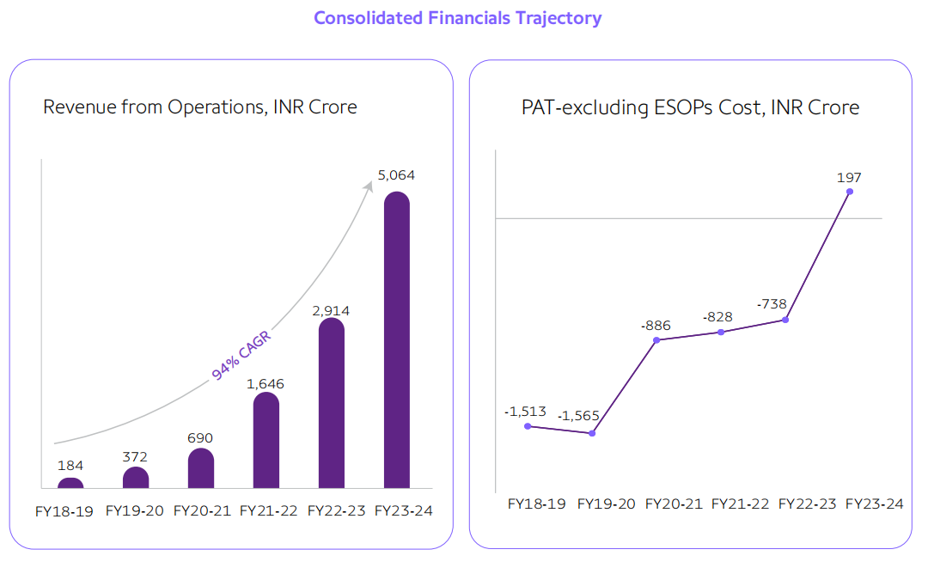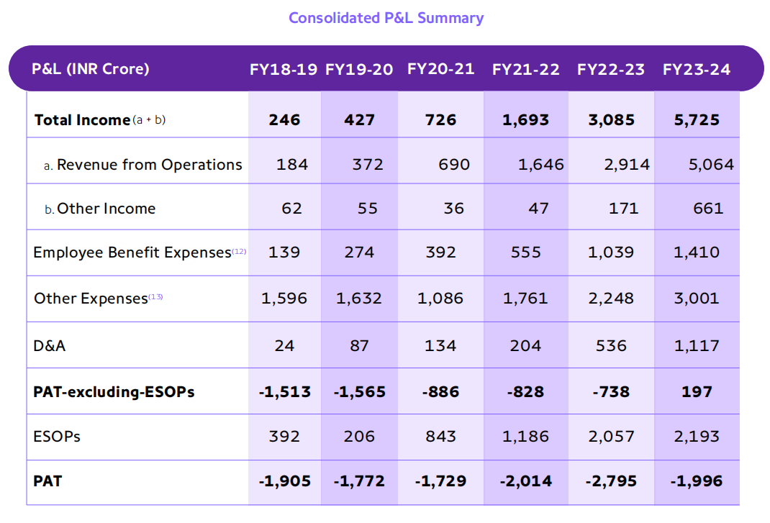

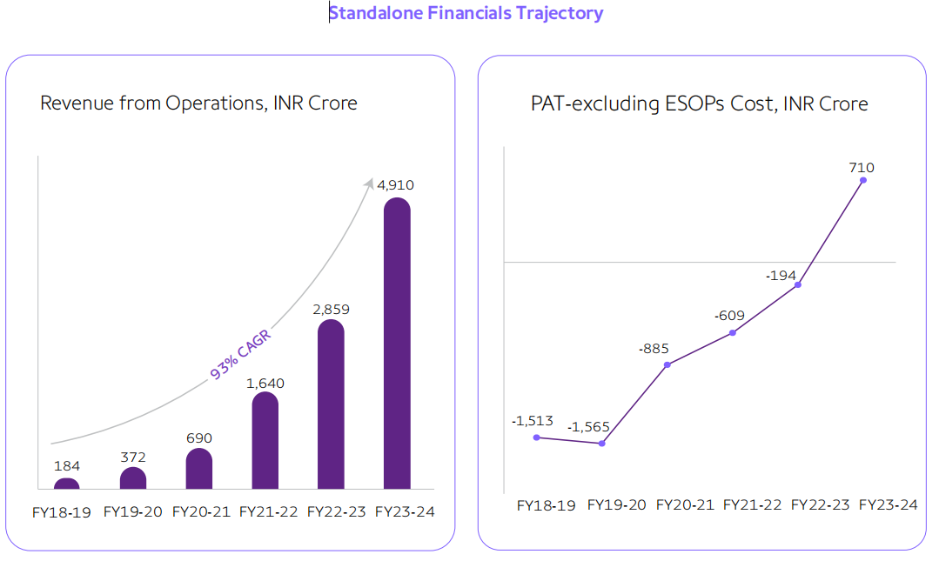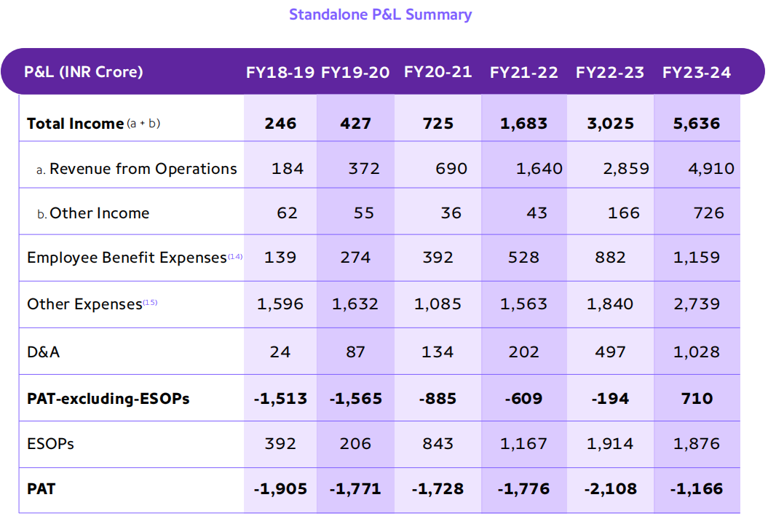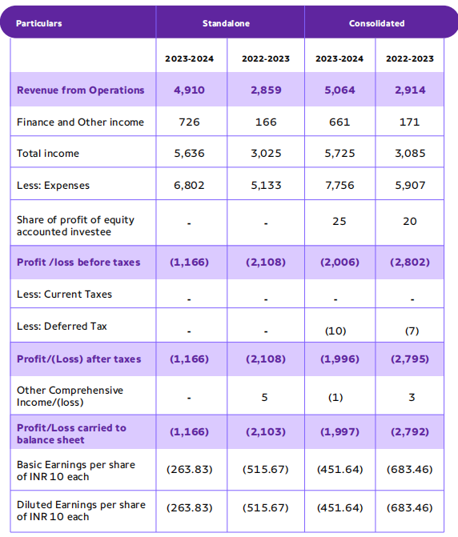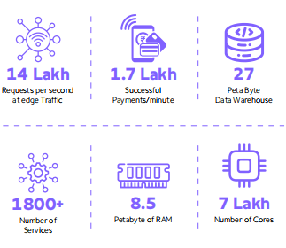

**Current Challenges and Solution for Phonepe**

**PhonePe’s Strategy to Reduce UPI Market Share & Increase Profitability**

**The Core Challenges:**

**Over-Reliance on UPI –** No direct revenue from UPI due to Zero MDR, except for wallet-based UPI transactions.

**Zero MDR Challenge –** Since merchants don’t pay any MDR on UPI transactions, PhonePe faces revenue loss while still bearing infrastructure costs. It must find alternative monetization strategies to sustain operations.

**Regulatory Pressure –** RBI mandates that no single player can hold more than 30% of the UPI market share by 2026, which forces PhonePe to strategize market balance while maintaining dominance.

**Competitive Risk –** Intense competition from Google Pay, Paytm, and newer fintech players threatens market share. Losing users could reduce engagement, transaction volume, and data leverage for future business growth.

**Need for Profitability –** Without MDR on UPI, PhonePe must diversify its revenue sources through lending, insurance, stockbroking, and ONDC-based shopping while staying within the 30% market cap limit.

**Popularizing & Advertising Subsidiary Apps –** PhonePe is expanding into multiple sectors, including insurance, lending, and stockbroking through its subsidiary apps. However, these apps require strong marketing, user trust, and adoption to contribute significantly to revenue.

**Payment Delays & Processing Time** – One of PhonePe’s major challenges is transaction delays, where payments can take 4-5 seconds or even longer to process. Users often experience failed or late payments, leading to frustration and a loss of trust. Faster and more reliable transactions are crucial to maintaining a competitive edge.

**Step-by-Step Plan to Address These Challenges**

**Step 1️: Reduce Market Share in a Controlled Manner (Strategically)**

**Goal:** Comply with RBI regulations without significantly affecting revenue.  
 **How?** Shift focus **away from low-value transactions** while retaining high-value users.

**Encourage low-value users to switch to competitors (Google Pay, Paytm, etc.)**

* Target **users with small, infrequent transactions** to reduce dependency.
* Competitors can absorb these low-MDR users while PhonePe retains **high-value customers**.

**Prioritize High-Value UPI Users**

* Retain users who make large-ticket transactions, pay bills, or use PhonePe for investments and lending.
* Offer **exclusive perks** (cashbacks, rewards, better service) for high-value users.

**Outcome:**  
 PhonePe’s UPI market share **naturally reduces to 30%**, but the retained users generate higher revenue through other services.

**Step 2️: Increase Revenue from Existing Users (Beyond UPI)**

**Goal:** Monetize users effectively while keeping engagement high.

**Key Challenges in Monetizing Pincode App**

**No Seller Review System** – Lack of customer trust due to **no ratings & reviews** for merchants.  
I**nefficient A/B Testing** – Need for extensive **experiments on UI, pricing models, and promotions** to maximize conversion.  
L**ogo & Branding Issues** – Pincode lacks strong visual recall compared to Flipkart, Amazon, or JioMart.  
**Merchant Retention & Activation** – Many local sellers **onboarded but not actively using the platform**.  
**Logistics & Delivery Challenges** – Dependence on third-party logistics partners leads to **high costs & delays**.

**Strategies to Monetize & Scale Pincode App Effectively**

**1️ Introduce Seller Ratings & Reviews**

**Allow customers to rate & review local sellers** to improve credibility.  
 **Reward high-rated sellers** with a "Top Seller Badge" to build customer trust.  
 **AI-powered fake review detection** to prevent spammy ratings.

**2️ Smart A/B Testing for Higher Conversions**

**Test different layouts, CTAs, and pricing models** for best-performing UI.  
 **Experiment with free vs. paid delivery options** to see which drives more orders.  
 **Segment users (new vs. old) for customized discounts** and push notifications.

**3️ Stronger Branding & Visibility**

**Better logo placement & ad positioning** in the PhonePe app.  
 **Leverage PhonePe’s UPI traffic** by cross-promoting Pincode within the payments flow.  
 **Offer discounts & cashback incentives** for first-time buyers.

**4️ Increase Merchant Engagement & Activation**

**Tiered Commission Model** – Lower commission for **new merchants** in the first 3 months.  
 **Exclusive Seller Benefits** – Early payments, lower transaction fees, and more visibility for active sellers.  
 **Easy Order Management Dashboard** for local kirana stores with **voice-based order tracking**.

**5️ Optimize Delivery & Logistics**

**Partner with local delivery startups** (Dunzo, Shadowfax) for cheaper last-mile delivery.  
**Enable hyperlocal pickup points** for self-collection to reduce costs.  
**PhonePe Express Delivery** – Introduce a **1-hour guaranteed delivery** for essential items.

**6️ Monetization & Revenue Strategies**

**Seller Commissions** – Charge a **tiered commission (5-12%)** based on category & seller size.  
 **Sponsored Listings** – Let sellers **pay to rank higher in search results** for better visibility.  
 **Ads & Promotions** – Offer **homepage banners, featured deals, and push notifications** as paid promotions.  
 **Premium Subscription for Merchants** – Offer a paid plan with **priority support, free ads, and early payouts**.

**2️ Expand POS Machine Usage 💳**

UPI has **zero MDR**, but **card transactions have ~1.5%-2.5% MDR**.  
 Offer **affordable POS devices** for small businesses (like **Pine Labs & Paytm POS**).  
 Revenue Model:  
 Earn **MDR on card transactions**.  
 Charge merchants a **monthly subscription fee** for PhonePe POS.  
 Provide **merchant analytics** as a paid service.  
 **Why it works?** Encouraging **credit & debit card payments** helps capture revenue **without relying on UPI MDR**.

**3 Grow in WealthTech – Stock Trading & Investments 📈**  
Since **PhonePe already has a share market platform**, the goal should be to **differentiate it from competitors (Zerodha, Groww, Upstox, etc.)** and create a **strong brand identity** in the WealthTech space. Here are some key strategies:

**1️ Positioning & Differentiation**

**Target First-Time Investors** – Simplify stock market investing for beginners (just like Groww did).  
 **Focus on User Trust & Security** – Highlight PhonePe’s reliability in payments as a **trust factor for investing**.  
 **Integrate with UPI & Wallet** – Make funding a stock account **instant & seamless** via UPI & PhonePe wallet.  
 **Go Beyond Stocks** – Offer **pre-built portfolios, IPO investments, government bonds, and fractional investing**.

**2️ Strong Brand Awareness & Marketing**

**Leverage Existing UPI Users** – Run in-app ads & push notifications for stock trading inside the PhonePe app.  
 **Influencer Marketing** – Partner with **finance YouTubers, investment bloggers & Twitter/X influencers**.  
 **Educational Campaigns** – Offer **free stock market courses**, webinars, and explainers to attract new investors.  
 **Referral & Rewards** – Give cashback or **free brokerage credits** for referring friends.

**3️ Monetization Strategy (Beyond Brokerage)**

**Subscription Plans for Advanced Features** (like advisory, advanced charts, AI-based insights).  
 **Stock Lending Feature** – Allow users to **earn interest by lending their idle stocks** (Zerodha does this).  
 **Investment in IPOs, Bonds & ETFs** – Encourage long-term investing beyond just stocks.  
 **Integration with Insurance & Lending** – Cross-sell **insurance for stock investors & margin trading loans**.

**4️ Seamless User Experience & Trust**

**One-Click KYC & Onboarding** – Use PhonePe’s existing KYC database for **super-fast** account opening.  
**AI & Robo-Advisory for Smart Investing** – Offer **AI-driven investment suggestions** based on user profiles.  
**Transparent Pricing Model** – Keep brokerage fees competitive, ideally **zero brokerage for delivery trades**.  
**Fastest Order Execution & No Downtime** – Ensure **lightning-fast order execution & real-time price updates**.

**5️ Strategic Expansion & Partnerships**

**Partner with SEBI-Registered Advisors** – To provide **trusted investment recommendations**.  
**Collaborate with Mutual Fund Houses** – To **sell direct mutual funds** (like Zerodha Coin & Groww).  
**Expand to Global Investing** – Allow **Indians to invest in US stocks & ETFs**, just like INDMoney.

**How PhonePe Can Increase Profits from Indus Appstore 📱**

Since PhonePe already has Indus Appstore, the focus should be on user acquisition, developer onboarding, and monetization to make it a profitable alternative to Google Play.

**1️ Boost Developer Adoption & Exclusive Apps**

**Lower Commission Fees –** Offer a lower cut (e.g., 10-15% vs. Google’s 30%) to attract app developers**.  
 Exclusive Indian Apps** – Onboard Indian fintech, e-commerce, gaming, and utility apps that cater to regional audiences.  
 **Indie Developer Support –** Provide free hosting for new developers & zero commission for the first 6 months to drive adoption.  
 **Faster Approval & Easy Monetization –** Ensure fast app approval & smooth integration for in-app purchases & UPI payments.

**2️ Monetization Strategy for Higher Revenue**

**Commission on Paid Apps & In-App Purchases –** Charge 10-15% commission from premium apps & in-app purchases. **Ad Revenue from Featured Apps –** Charge developers to promote their apps via banner ads & featured sections.  
 **Subscription Model for Developers** – Offer a premium listing package where devs get:

* **Better app visibility in search results.**
* **Analytics dashboard for user insights.**
* **App marketing tools to drive downloads.  
  💰 Indus Coin / Loyalty Program –** Introduce a virtual currency where users earn cashback for purchases, increasing transactions.

**3️ User Growth & Market Expansion**

**Deep Integration with PhonePe –** Make app downloads & purchases seamless via UPI & PhonePe Wallet.  
**Exclusive App Deals & Discounts –** Offer limited-time free apps or discounted subscriptions to attract users.  
**Pre-installation Partnerships** – Partner with Indian smartphone brands (Micromax, Lava, etc.) to pre-install Indus Appstore.  
**Multilingual Interface –** Expand in regional languages to tap into Tier-2 & Tier-3 city users.  
**Indus Appstore Lite for Feature Phones –** A lightweight version for low-end Android devices.

**4️ Competing with Google Play Store**

**No Google Restrictions** – Market Indus Appstore as an open platform with no forced Google Play policies.  
 **Direct UPI & Wallet Payments –** Unlike Google Play, Indus can allow UPI payments without extra Google fees.  
 **India-First Positioning –** Focus on Indian developers & apps that aren’t prioritized on Google Play.  
 **Game Monetization** – Offer higher revenue share & localized payment options for mobile gaming apps.

**5️ Long-Term Expansion Strategy**

**Partner with Major Indian Apps –** Ensure apps like Hotstar, JioCinema, Zomato, Paytm, and Myntra list exclusively or early on Indus.  
**Launch App Developer Fund –** Invest in Indian app startups to build apps exclusively for Indus Appstore**.  
Expand to Smart TVs & Wearables –** Build an Indus Appstore for Smart TVs & Smartwatches (like Samsung & Apple do).  
**AI-Based App Recommendations –** Use AI to suggest personalized app recommendations to users

**5️ Scale Lending & Credit Products**

Introduce **loans, BNPL (Buy Now, Pay Later), and co-branded credit cards** with banks & NBFCs.  
 Revenue Model:  
 Earn **commissions from loan disbursements**.  
 **Interest & late fees** on lending products.  
Partner with banks for **PhonePe-branded credit cards**.  
 **Why it works?** PhonePe already has **detailed user transaction data** that can be leveraged for targeted lending.

**Final Execution Strategy: Long-Term Profitability Plan**

**Retain High-Value Users** – Focus on users who **spend more & use financial services**.  
 **Expand into Financial Services** – Stock trading, lending, insurance, and BNPL.  
 **Smart Data Monetization** – Use AI/ML for personalized recommendations **without violating privacy norms**.  
 **Boost POS Machine Adoption** – More **card transactions = more MDR revenue**.  
 **Digitize Small Businesses** – Increase merchant engagement via **Pincode, POS, & lending services**.

**📌 Conclusion: The Best Path Forward**

🔹 **PhonePe must shift from UPI dominance to a diversified fintech business.**  
🔹 Instead of fighting for 50% UPI share, **retain the most profitable 30%**.  
🔹 **Invest heavily in financial services, commerce, and lending** to build a **sustainable revenue model**.  
🔹 PhonePe can **outgrow its competitors not by UPI volume, but by deeper monetization strategies**.

**Transaction-Latency Issue**

One of the **biggest pain points** in digital payments today is the **4-5 second delay in completing UPI transactions**. Since **fintech users are highly switchable** to other platforms, **solving this issue is critical for PhonePe to maintain leadership.**

**Reduce UPI Transaction Time: The Immediate Need**

**UPI transaction time must be reduced** → Instant transactions improve user experience and retention.  
**Fintech users have no loyalty** → If transactions fail or take too long, they immediately switch to **Google Pay, Paytm, or banking apps**.  
**Reducing dependency on banks** → Load balancing through **wallets & UPI Lite** can ease bank infrastructure pressure.

**Smart Solutions to Improve Transaction Speed**

**Direct Users Towards Wallets & UPI Lite for Small Transactions**

* For payments **below ₹500**, users should be auto-suggested to use **UPI Lite or PhonePe Wallet**.
* **UPI Lite transactions happen instantly** because they do not require direct bank authentication every time.
* **This reduces the load on banks**, making overall UPI payments faster.

**Example:**

* A user paying **₹100 for chai** doesn’t need full UPI processing → Suggest **UPI Lite** for instant transactions.
* A user transferring **₹50,000 rent** should continue using full UPI with bank authentication.

**Impact:**  
✔ **Faster transactions for users.**  
✔ **Less burden on bank servers.**  
✔ **Improves transaction success rate.**

🔹 **Heavy Investment in Tech Infrastructure**

* **Invest in AI-based load balancing** → Route payments through the fastest available UPI gateway.
* **Pre-validate transactions** for regular payments (e.g., recurring electricity bills) to **avoid repeated authentication delays**.
* **Partnership with NPCI & banks** to improve UPI infrastructure speed.

**Example:**

* **Real-time routing of transactions** through multiple banking partners based on current network speed.

**Impact:**  
 **Ensures PhonePe is the fastest UPI platform.**  
**Retains users who prefer instant payments.**

**Why This Matters for PhonePe?**

**Users don’t wait → They switch!** A delay of even **2-3 seconds** can push a user to **Google Pay or Paytm**.  
**Solving this will make PhonePe the fastest UPI app**, leading to **higher retention & more transactions**.  
**Less load on banks = Fewer failed transactions** → Overall better experience for users.

**If PhonePe solves this problem, it will become India’s fastest & most reliable UPI platform, making it nearly impossible for users to switch!**

**1. Driving Merchant Adoption for Credit Cards, Debit Cards & Wallets**

**Incentivized Lending for POS Deployment**

🔹 **Challenge:** Small merchants hesitate to buy a POS machine due to upfront costs.  
🔹 **Solution:** PhonePe can offer **low-interest micro-loans** (based on transaction data) to help merchants deploy POS machines.  
🔹 **Impact:** Faster merchant onboarding → increased transaction volumes → higher revenue from MDR.

**Example:** A Kirana store with limited cash flow can get a loan to install a POS, making it easier to accept high-value payments.

**Merchant Education on Benefits of Card Payments**

🔹 **Many merchants still prefer UPI due to zero MDR**, but PhonePe can highlight:

* **Higher spending capacity** of credit card users.
* **Reduced payment failures** compared to UPI.
* **EMI options for customers**, increasing sales.  
  🔹 **Tactics:**
* Local merchant onboarding campaigns.
* Partnering with **banks & NBFCs** to offer cashback for credit card usage.
* **Referral incentives** for merchants bringing in new businesses.

📌 **Example:** A mobile shop can upsell expensive phones if customers can pay via credit cards and EMI.

**Prioritizing Lending: High-Profit, High-Potential Market**

**🔹 Why Lending Over Other Ventures?**

**Lending & Insurance have much higher profit margins** compared to standalone businesses like **Indus and PinCode.**  
 **PinCode and Indus require brand-building from scratch**, whereas lending benefits directly from **PhonePe’s existing trust & data.**  
**PhonePe already has deep rural penetration** → **80% of traction comes from outside the top 10 cities**, making it a **goldmine for lending.**

**Current Gap:**

* Many rural and Tier-3 city consumers still **borrow at high-interest rates from local lenders**.
* **Formal credit penetration is low** → PhonePe can **tap into this underserved segment** with a **data-driven credit model**.

**How PhonePe Can Win in Lending**

🔹 **Build AI-Based Consumer Credit Profiles:**

* Analyze **average monthly spending, balance at month-end, EMI payments & repayment patterns.**
* Create **a risk-based lending model** → High-risk borrowers get **higher interest rates**, low-risk loyal users get **low-interest loans**.
* Focus on **micro-loans** and **small-ticket financing**, which are highly profitable in rural markets.

🔹 **Deep Rural & Tier-3 Focus for High Profits:**

* **Rural India has massive unmet credit demand**, and **borrowers pay much higher interest rates** to informal lenders.
* PhonePe can **offer slightly lower rates** while still maintaining **high profitability.**

**Example:**  
A farmer needing ₹10,000 for a seasonal expense might borrow at **30-40% interest from a local moneylender**. PhonePe can **offer at 18-20%**, ensuring both **affordability for the borrower** and **profitability for PhonePe**.

**Impact:**  
 **PhonePe can dominate micro-lending in Tier-3 & rural areas.**  
 **Utilizes existing customer base for rapid scaling.**  
 **AI-based credit risk assessment ensures high repayment rates.**

**2. Insurance: Strengthening Trust & Recurring Revenue**

**🔹 Why Insurance is Key for Long-Term Growth?**

Unlike standalone businesses, **insurance has recurring revenue & strong customer retention**.  
 **PhonePe already handles transactions → Easy cross-sell for insurance.**  
 **Insurance is highly profitable if claims are managed well.**

**Strategy to Win in Insurance**

🔹 **Personalized Insurance Offers Using Consumer Data**

* PhonePe can **analyze spending patterns** to **offer targeted insurance plans**.
* Example: **Users who book travel tickets often** → Auto-offer **travel insurance.**
* **Frequent hospital bill payments** → Suggest **health insurance plans.**

🔹 **Deep Penetration in Tier-3 & Rural Areas**

* **Low insurance penetration in rural India = Huge untapped market.**
* Provide **small-ticket health & accident insurance policies** with easy claim processes.

**Example:**  
A rural worker earning ₹10,000/month might never consider **health insurance**, but a **₹100/month plan covering hospital expenses** could be attractive.

**Impact:**  
✔ **Boosts profitability through premium collection.**  
✔ **Creates recurring revenue streams.**  
✔ **Strengthens consumer trust in PhonePe’s financial ecosystem.**

**Shift Focus: No More Diversification for 2 Years**

**Why PhonePe Should Pause Diversification?**

* **Expanding into multiple new businesses at once dilutes focus & profitability.**
* **Indus & OneCode need major brand-building efforts** before they generate returns.
* Lending & insurance **offer immediate, high-margin revenue opportunities**.

**By focusing on lending & insurance, PhonePe can build a sustainable, high-profit business before considering further expansion.**

**PhonePe’s IPO Strategy: Ensuring Profitability & Market Leadership Before Going Public**

PhonePe is one of India's strongest fintech players, but before going public, **it must learn from Paytm’s mistakes** and **focus on sustained profitability**. A well-planned IPO can make PhonePe a dominant force in the global fintech space.

**1️ Why PhonePe Should Delay IPO Until 2027**

**Learning from Paytm’s Failure:**

* Paytm **went public too soon** without a clear **path to profitability**.
* Overhyped valuation but **no strong earnings** → Stock **crashed after listing**.
* Weak monetization strategy **led to investor distrust** → Heavy losses post-IPO.

**Why PhonePe Should Wait Until 2027:**  
**NPCI’s Market Cap Deadline (2024-2025):** Once NPCI’s 30% market share cap is enforced, PhonePe can assess its real standing.  
 **Investor Confidence:** Waiting allows PhonePe to **prove long-term revenue stability**, attracting stronger investors.  
 **Stronger Financials:** If PhonePe becomes **profitable before IPO**, its valuation will be **more sustainable** and attractive.

**Best Time for IPO?** **Post-2027**, when PhonePe has solidified its revenue streams and **proven resilience in the fintech market**.

**2️ Ensuring Profitability Before IPO**

For a successful IPO, **PhonePe must show strong profits in core business areas**.

**Expand Lending & Insurance Business (Highest Profit Margins)**

* Lending & insurance **are more profitable than UPI** (which is mostly free).
* **Focus on Tier-3 & Rural Areas** where people still take high-interest loans.
* **Use PhonePe’s transaction data** to build **personalized credit risk profiles**:
  + **Low-risk customers** → Lower interest rates for long-term trust.
  + **High-risk customers** → Higher interest rates to offset potential defaults.

**Why This Works?**

* Paytm failed because its lending model wasn’t **data-backed**.
* PhonePe has **better customer insights** (spending behavior, savings, EMI history).

**Target High-Margin Sectors (Wealth Management, BNPL, Insurance)**

* Launch **PhonePe Wealth**: Mutual funds, stocks, and digital gold for young investors.
* **Buy Now, Pay Later (BNPL)**: Offer easy financing for small online purchases.
* **Micro-Insurance for Rural India**: Low-cost insurance plans for farmers & small businesses.

**Monetize Seller Promotions & Ads**

* **UPI is free**, but PhonePe can charge merchants for:
  + **Sponsored seller placements** (like Amazon/Swiggy).
  + **Premium visibility for top-rated sellers.**
* **Personalized Offers Using PhonePe Data:**
  + If a user spends a lot on **gym memberships**, promote **healthy food & fitness products**.

**Impact:**  
✔ **Diversified revenue beyond UPI** → Long-term sustainability.  
✔ **More profitability before IPO** → Higher investor confidence.

**IPO Strategy: Attracting Big Investors**

Once PhonePe is profitable, the IPO should focus on **attracting long-term institutional investors**, not just retail hype.

**How to Make PhonePe’s IPO a Success?**  
 **Prove Strong Revenue Streams Before Listing:**

* Show growth in **lending, insurance, and merchant services**, not just UPI transactions.

**Avoid Overvalued IPO Pricing:**

* Paytm’s IPO was overvalued **(₹18,300 Cr, but loss-making)** → Investors lost confidence.
* PhonePe should **price fairly** based on real growth, **not just hype**.

**Use Walmart & Tiger Global’s Backing Smartly:**

* These investors bring credibility but **must stay post-IPO** to maintain stability.

**Final Goal?**  
 **Sustainable, high-margin fintech company.**  
 **Strong IPO that attracts serious investors, not just traders.**  
 **Market leadership in lending, insurance & digital finance.**

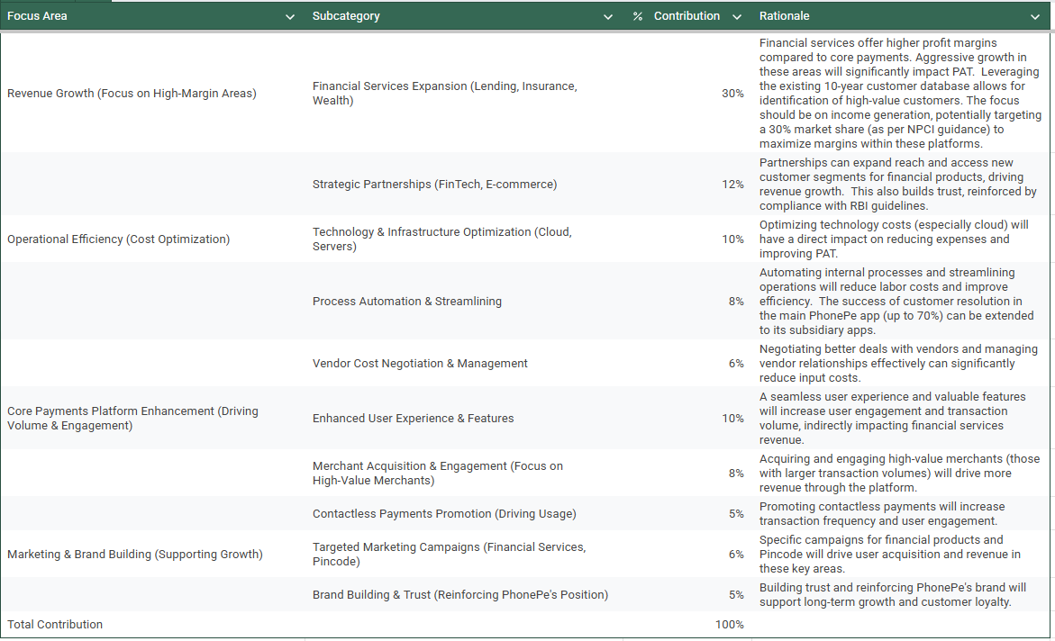

**Database Management & Schema Design**

**Schema Design**

**Question:** Based on the features and functionalities you have identified, design a schema that reflects the platform’s data structure. Define the key entities, attributes, and relationships that underpin these features.

**Answers: Schema Design for PhonePe**

The schema design for PhonePe should reflect its core features and functionalities, ensuring efficient data management and enabling the platform to deliver a seamless user experience.

**Database Design Summary:**

We've designed a database schema for a multi-application platform (like PhonePe) using a **centralized user data model**. The core of this design is the universal_phonepe_user table. This table stores core user information (name, contact details, unique UPI ID, etc.) and acts as the single source of truth for user identity.

Each application (e.g., main PhonePe app, Pincode, Market) has its own set of tables, but these tables *do not* store the user's core information directly. Instead, they link back to the universal_phonepe_user table using a user_id (a foreign key). This user_id is a unique identifier for each user within the universal_phonepe_user table.

**Our Approach (Centralized):**

Our approach is based on the principle of **centralization**. All user data is managed in one central location. This is a fundamental and highly recommended practice for multi-application systems. It's vastly superior to having separate user databases for each app, which would lead to data duplication, inconsistencies, and significant management overhead.

**Benefits of the Centralized Approach:**

* **Data Consistency:** User information is stored in one place, ensuring consistency across all applications. Updates to user profiles are automatically reflected everywhere.
* **Reduced Redundancy:** No data duplication, saving storage space and simplifying data management.
* **Improved Data Integrity:** Constraints (like UNIQUE on unique_upi_id and foreign key relationships) enforce data integrity, preventing inconsistencies.
* **Scalability:** Easier to scale the system as new apps are added.
* **Simplified Development:** Developers don't have to manage user identity in each app individually.
* **Auditability:** Centralized data makes auditing easier.
* **Compliance:** Helps with regulatory compliance (especially for financial data).

**Connecting the Dots (High-Value Customers, Patterns):**

Because all app data is linked back to the universal_phonepe_user table, we can easily "connect the dots" between a user's activity in different apps. We can use SQL queries to identify patterns, such as:

* Users who are both consumers and investors.
* High-value customers based on transaction volume.
* Users who are both sellers and investors.
* Users who frequently use travel bookings and invest in wealth plans.
* Users who are high spenders on food and have active loans.

**Incentives and Monetization:**

* **Targeted Incentives:** The identified patterns allow for targeted incentives to specific customer segments.
* **Personalized Recommendations:** Data can be used to provide personalized recommendations.
* **Data Monetization (Ethically and Carefully):** Anonymized and aggregated data can be used to identify market trends and offer insights to businesses. *Data privacy and ethical considerations are paramount.*
* **Premium Features:** Offer premium features to high-value customers.
* **Loyalty Programs:** Implement loyalty programs to reward frequent users.

**Key Considerations (Data Privacy, Performance, etc.):**

* **Data Security:** Protect sensitive user data with strong security measures.
* **Performance:** Optimize database queries and consider sharding as the data grows.
* **Data Governance:** Establish clear data governance policies.
* **API Design:** Design a secure and efficient API for accessing user data.
* **Data Migration:** Plan carefully for data migration from existing systems.
* **Testing:** Thoroughly test all app integrations.
* **Error Handling:** Implement robust error handling.
* **Future Apps:** Design should be flexible for future apps.

In summary, this database design provides a solid foundation for a multi-application platform. The centralized approach offers many benefits in terms of data consistency, integrity, and scalability. By leveraging the data effectively and prioritizing data privacy, you can gain valuable insights into your customer base, offer personalized services, and drive revenue growth.

**Entity-Relationship (ER) Table-Indus app**

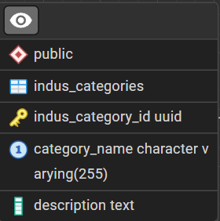 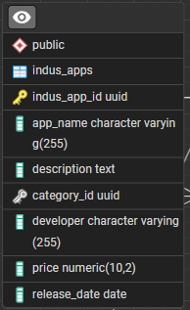 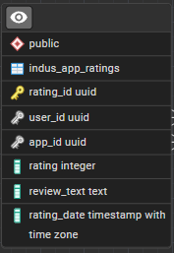 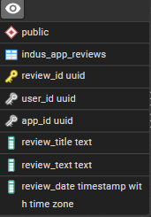

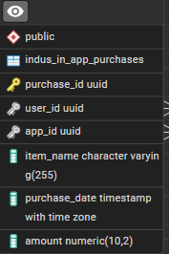 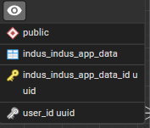 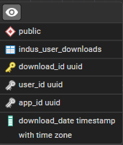 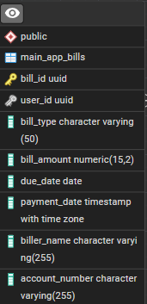

**Entity-Relationship (ER) Table-MAIN Phonepe app**

 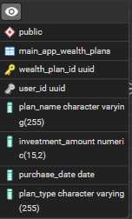 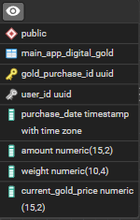 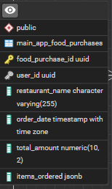 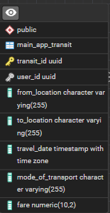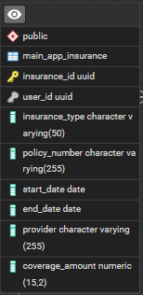

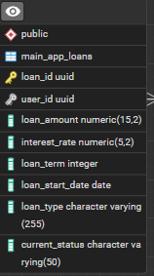 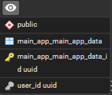 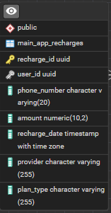 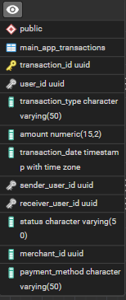 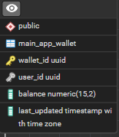

**Entity-Relationship (ER) Table- Market app**

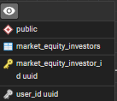 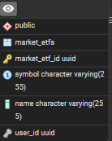 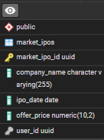 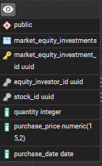 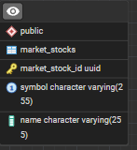 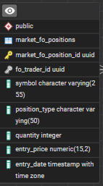 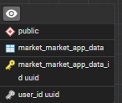 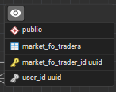 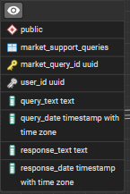

**Entity-Relationship (ER) Table- Pincode app**

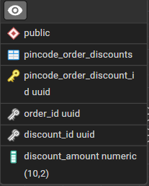 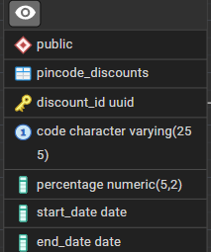 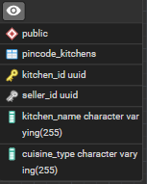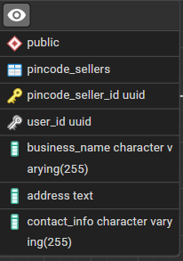 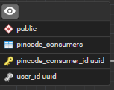 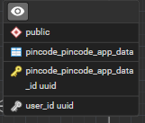 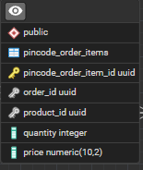

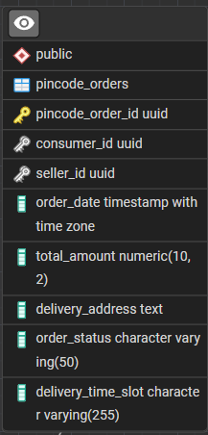 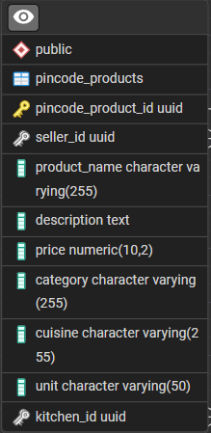 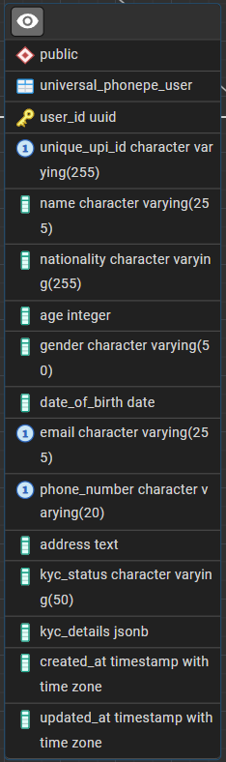

**Entity-Relationship Diagram (ERD)**

**Snap of ERD**

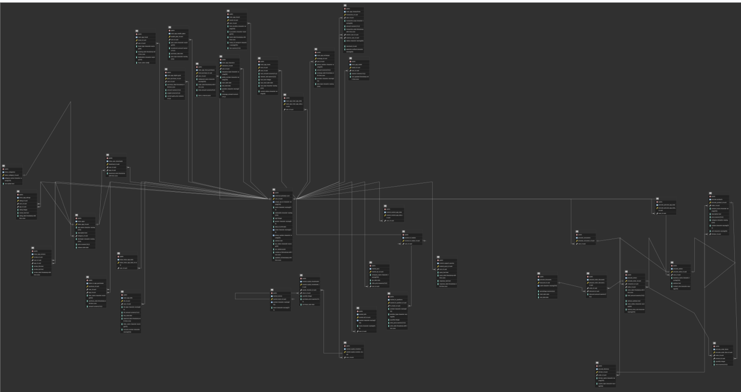

**Phonepe Revenue Sources:**

PhonePe's revenue can be categorized as follows, keeping in mind the zero MDR impact on UPI transactions:

* **Core Payments Platform (Main PhonePe App):**
  + **Commissions:** Bill payments, recharges (mobile, FASTag, etc.), travel bookings (bus, train, flights), and potentially other commissions from partnered services.
* **Financial Services:**
  + **Insurance:** Commissions on premiums (health, term life, motor, etc.).
  + **Wealth Management (Share.Market):** Brokerage fees, commissions on mutual fund investments, potentially advisory fees.
  + **Lending:** Interest income from loans (personal loans, etc.).
* **E-commerce (Pincode):**
  + **Commissions/Fees:** Percentage-based fees from sellers on each transaction.
  + **Advertising (potentially):** Revenue from sponsored listings or other forms of advertising on the Pincode platform.
* **App Store (Indus App Store):**
  + **Commissions:** Percentage of app sales or in-app purchases.
  + **Advertising (potentially):** Revenue from app promotions or other advertising within the app store.
* **Trading Platform (Market):**
  + **Brokerage Fees:** Fees charged per trade or transaction.
* **PhonePe Business:**
  + **Merchant Solutions:** Fees for payment gateway integration, QR code services, and other business tools.
  + **Advertising/Promotions:** Revenue from businesses promoting their products or services on the PhonePe platform.
* **UPI International:**
  + **Transaction Fees:** Fees charged on international UPI transactions.

**Expense Categories:**

* **Employee Benefits:**
  + **Salaries and Wages:** Payments to employees.
  + **ESOPs (Employee Stock Options):** A significant expense, especially in a competitive tech environment.
  + **Other Benefits:** Health insurance, retirement contributions, etc.
* **Technology & Infrastructure:**
  + **IT Infrastructure:** Servers, data centers, cloud computing costs.
  + **Software Development & Maintenance:** Developing new features, maintaining the platform, security updates, etc.
* **Marketing & Advertising:**
  + **User Acquisition:** Campaigns to attract new users to all PhonePe apps.
  + **Brand Building:** Advertising to strengthen the PhonePe brand.
  + **Platform Marketing:** Promoting specific features or services within the apps.
* **Payment Processing Costs:**
  + **Bank Charges:** Fees paid to banks and payment networks for processing transactions (even for UPI, there are some underlying costs).
  + **Settlement Costs:** Costs associated with settling transactions between different parties.
* **Customer Support:**
  + **Support Staff:** Salaries and training for customer support representatives.
  + **Support Tools & Infrastructure:** Software and systems used for customer support.
* **Operational Expenses:**
  + **Rent & Utilities:** Office space and related costs.
  + **Legal & Professional Fees:** Legal, accounting, and consulting expenses.
  + **Other Overheads:** Office supplies, travel, etc.
* **Losses from Financial Services:**
  + Potential losses from lending activities (loan defaults).

**4. Customer Acquisition & Retention Analysis for PhonePe**

**Customer Acquisition Channels**

**Channels**

* **Social Media Platforms**:
  + Platforms like Facebook, Instagram, and Twitter are used to run targeted ads and campaigns.
  + PhonePe also engages in influencer marketing to enhance visibility.
  + Campaigns are optimized for specific demographics and regions.
* **Search Engines**:
  + Search Engine Marketing (SEM) through platforms like Google Ads brings in users searching for payment solutions.
  + Search Engine Optimization (SEO) ensures PhonePe ranks high for relevant keywords like "UPI payment app" or "best payment app in India."
* **Referral Programs**:
  + PhonePe incentivizes existing users to refer the app to others by offering rewards like cashback or discount coupons.
  + Referral campaigns are tailored to both merchants and customers to expand the user base.
* **Advertising Campaigns**:
  + Offline and online campaigns include TV commercials, billboards, and digital banners to attract a wide audience.
  + Sponsorships for major events or shows (e.g., IPL partnerships) provide mass outreach and increase downloads.

**Effectiveness**

* **Acquisition Cost Analysis**:
  + **Social Media Ads**: While these are cost-effective for specific demographics, frequent optimization is needed to reduce cost-per-acquisition (CPA).
  + **Search Engine Ads**: Slightly higher CPA but useful for attracting high-intent users.
  + **Referral Programs**: Highly effective due to the trust factor between referrer and new users, resulting in better retention rates.
  + **Advertising Campaigns**: Expensive but increases mass visibility and credibility.
* **Customer Conversion Rates**:
  + Track which channels lead to the highest downloads and user activations.
  + Compare costs of each campaign to ensure budget allocation aligns with ROI.
  + Evaluate campaign effectiveness using metrics like CTR (Click-Through Rate) and CAC (Customer Acquisition Cost).

**Understanding Customer Behaviour and Retention**

**Customer Data Analysis**

* **Purchase and Transaction History**:
  + Track the frequency of transactions, average transaction value, and preferred payment modes (e.g., UPI, wallet, or card).
  + Segment users into categories such as high-frequency users, occasional users, and dormant users.
* **Browsing Patterns**:
  + Analyze how users navigate through the app—features they explore (e.g., bill payments, QR payments) and sections they abandon.
  + Identify bottlenecks like confusing UI/UX or unresponsive features.
* **Feedback Collection**:
  + Use in-app surveys, app store reviews, and customer support interactions to gather insights into user pain points and expectations.
  + Address recurring issues like failed transactions, delays, or complex app navigation.

**Retention Rates**

* **Calculation of Retention Rates**:
  + Retention Rate = [(Users at the end of the period - New Users Acquired) / Users at the start of the period] * 100
  + Measure this monthly, quarterly, and annually to identify trends.
* **Loyalty Drivers**:
  + offers for repeat transactions encourage loyalty.
  + Exclusive perks like zero transaction fees for frequent users or early access to new features.
* **Segmentation of Retained Users**:
  + Retain users by targeting specific groups with personalized offers.
  + For example, offer free insurance for high-value users or loyalty rewards for merchants.

**.Churn Analysis**

* **Reasons for Churn**:
  + **Technical Issues**: Failed or delayed transactions, app crashes, and poor network handling.
  + **Competitor Attraction**: Users lured by higher cashback or better offers from competitors like Google Pay or Paytm.
  + **Lack of Engagement**: Dormant users who haven’t received personalized offers or reminders.
* **Strategies to Reduce Churn**:
  + **Technical Improvements**: Optimize app performance and ensure transactions are seamless even in low-network areas.
  + **Engagement Campaigns**: Send personalized notifications and offers based on user activity.
  + **Reactivation Campaigns**: Offer exclusive benefits to users who haven’t transacted in a while.
  + **Customer Support Enhancements**: Proactively resolve issues and ensure prompt assistance through 24/7 support.

**PART - II**

**Guesstimates**

1. **What will be the percentage increase in global FinTech investments over the next five years?**

* This question involves estimating the growth rate of investments in FinTech startups and companies, considering current trends and future projections.

**Step 1: Current Global FinTech Investments**

* In 2024, global FinTech investments amounted to approximately $52 billion annually.

**Step 2: Annual Growth Rate**

* Estimate an annual growth rate for global FinTech investments.  
  Assume an 8% annual growth rate (based on current trends).

**Step 3: Project Future Investments After 5 Years**

Use the formula for compound growth:

Future Value = Current Value×(1+Growth Rate)^n

Where:

* Current Value = $52  billion
* Growth Rate = 8% = 0.08
* n = 5 years

Future Value = 52 × (1+0.08)^5 = 52 × 1.46933 = **$77 billion**

**Step 4: Calculate the Percentage Increase**

Percentage Increase =( Future Value − Current Value / Current Value)×100

Percentage Increase = (77 − 52 / 52) ​× 100

      = **~ 50 %**

Based on an 8% annual growth rate, global FinTech investments are projected to grow to approximately $77 billion in five years, representing a 50% increase.

1. **How many people will adopt digital banking services in developing countries over the next decade?**

* This question requires an estimation of the number of new users of digital banking solutions in regions where traditional banking infrastructure is less prevalent.

**1. Population in Developing Countries**

* Current population of developing countries:  **~5 billion** (based on global estimates).
* Expected annual population growth rate: **1%**.
* Population after 10 years:

Future Population = Current Population×(1+Growth Rate)^n

Future Population = 5×(1+0.01)^10= **6 billion**

**2. Internet Penetration**

* Current internet penetration in developing countries: **50%** (source: World Bank).
* The expected annual growth rate of internet penetration: **5%**.
* Internet penetration after 10 years:

Future Penetration=Current Penetration×(1+Growth Rate)^n

Future Penetration = 0.50 (1 + 0.05)^{10}  = **0.814**

* Total internet users after 10 years:

Internet Users  =  Future Population×Future Penetration

                        =5.523×0.814

**≈ 5billion.**

**3. Adoption Rate of Digital Banking**

* Assume 60% of internet users in developing countries will adopt digital banking services over the next decade (due to increased smartphone use and fintech solutions).
* Total digital banking users:

 Digital Banking Users = Internet Users × Adoption Rate

Digital Banking Users = 5×0.60 = **3 billion**

Approximately **3 billion people** in developing countries are estimated to adopt digital banking services over the next decade.

1. **What percentage of small and medium-sized enterprises (SMEs) will use FinTech solutions for their financial needs by 2025?**

* This question involves predicting the adoption rate of FinTech services among SMEs, including payments, lending, and financial management tools.

Solution:

**Current Trends:**

* In 2023, **~30% of SMEs** globally use FinTech solutions (e.g., digital payments, lending platforms, accounting tools).
* Adoption is higher in developed markets (e.g., 50% in the US) and lower in developing markets (e.g., 20% in Africa).

**Assumptions:**

1. **Growth Rate**: Adoption will grow at **~10% annually** due to increased awareness, affordability, and regulatory support.
2. **SME Population**: There are **~400 million SMEs** globally.
3. **Drivers**: Digital payments, working capital loans, and automated accounting tools will drive adoption.

**Calculation:**

* **Current Users**: 30% of 400 million = **120 million SMEs**.
* **Annual Growth**: 10% of 120 million = **12 million new SMEs/year**.
* **By 2025 (2 years)**: 12 million × 2 = **24 million new SMEs**.
* **Total Users by 2025**: 120 million + 24 million = **144 million SMEs**.

**Percentage Adoption:**

* **Adoption Rate**: (144 million / 400 million) × 100 = **36%**.

**Final Answer:**

By 2025, approximately **36% of SMEs** globally will use FinTech solutions for their financial needs.

1. **What will mobile payments' average transaction value in the next three years?**

* This question requires estimating the average amount of money transacted through mobile payment platforms, considering the growth of mobile commerce and digital wallets.

**Current Trends:**

* In 2023, the average transaction value for mobile payments is **~$50**.
* Growth is driven by increased adoption of mobile wallets, QR codes, and contactless payments.

**Assumptions:**

1. **Growth Rate**: The average transaction value will grow at **~5% annually** due to inflation and higher adoption of premium services.
2. **Drivers**: E-commerce growth, higher disposable incomes, and increased use of mobile payments for larger transactions.

**Calculation:**

* **Year 1**:  50×1.05=52.50
* **Year 2**:  52.50×1.05=55.13
* **Year 3**:  55.13×1.05=57.88

**Final Answer:**

The average transaction value of mobile payments will increase to approximately **$58** in the next three years.

1. **How much will blockchain technology reduce the costs of cross-border transactions in the next five years?**

* This question involves estimating the cost savings achieved through adopting blockchain technology for international money transfers, factoring in current fees and the efficiency improvements blockchain brings.

We will estimate the **percentage reduction in costs** for cross-border transactions due to blockchain adoption.

**Step 1: Understanding the Current Costs of Cross-Border Transactions**

Currently, traditional cross-border transactions incur the following fees:

1. **Bank Processing Fees:** ~2–2.5% per transaction
2. **Intermediary Bank Charges:** ~1–1.5%
3. **Foreign Exchange Markup:** ~1–1.5%
4. **Other Miscellaneous Charges:** ~1%

**Total Cost for Traditional Cross-Border Transactions: ~6% of the transaction amount**

**Step 2: Estimating Blockchain-Based Cost Reduction**

Blockchain-based solutions (e.g., **Ripple (XRP), Stellar (XLM), and stablecoins (USDT, USDC)**) significantly reduce costs by:

* **Eliminating intermediaries** (0% intermediary bank fees)
* **Minimizing processing costs** (as low as 0.1–1%)
* **Reducing forex markups** (due to peer-to-peer exchange systems)

1. **Estimated Cost for Blockchain Transactions:** ~**1.5% of the transaction amount**

**Assumption:**

Adoption Rate: The projected Adoption Rate for the next 5 Years could be 40%, Adoption is increasing, but several factors (regulatory issues, trust, integration with banks, etc.) may slow it down.

**Step 3: Blended Cost Reduction Calculation**

We now calculate the **average cost reduction**, considering that blockchain-based transactions will make up only **40%** of the market, while 60% will still use expensive traditional methods.

**Weighted Average Cost in 2030**

New Average Cost = (0.6*6%) + (0.4*1.5%)

    = 3.6% + 0.6%

    = 4.2% (blended cost)

**Final Answer:**

By 2030, blockchain could reduce the average cost of cross-border transactions by approximately 30%, considering that only ~40% of transactions will shift to blockchain.

**PART - III**

**Scenario Based Questions**

**Scenario 1: Analyzing User Retention Rate**

A fintech company offers a **mobile payment app** that allows users to link their bank accounts and make payments. The company wants to analyze the **retention of users who signed up in the past six months** to understand how often they continue using the app after their initial download.

**Question 1: Performing Cohort Analysis for Monthly Retention Rate**

Cohort analysis helps track user retention by grouping users based on their signup month and monitoring their activity over time.

**Step 1: Data Collection**

* Gather user sign-up data for the past six months.

PhonePe had around 5 crore users in 2018, which has now increased to 50 crore users in 2024. From this, we can calculate the **Compound Annual Growth Rate (CAGR)** and the average annual growth percentage of users

CAGR=(Vi​/Vf​​)n1​−1

Where:

* Vf​ = Final value (Users in 2024) = **50 Crore**
* Vi​ = Initial value (Users in 2018) = **5 Crore**
* n = Number of years = **2024 - 2018 = 6**

**CAGR=(50/5)*(1/6)-1**

**=(10)*(1/6)-1**

**=(1.4678)-1**

**CAGR ≈0.4678 or 46.78%**

If this growth rate continues, we can estimate the number of users in the next few years. For example, by 2025, the predicted users would be:

**Users in 2025=50×(1+0.442)=72.1 crore**

**We already estimated:**

* **Users in 2024 = 50 crore**
* **Users in 2025 = 72.1 crore (using CAGR of 44.2%)**

**New users added in 2025:**

**72.1−50=22.1 crore72.1 - 50 = 22.1 crore**

**For our convenience, let's take 25 crore as the estimated new users due to the high possibility of growth.**

**Top of Form**

**Bottom of Form**

**Step 2: Define User Cohorts6**

* A **cohort** is a group of users who signed up in the same month.
* Example cohorts:
  + **January Cohort**: Users who signed up in January.
  + **February Cohort**: Users who signed up in February
  + **March Cohort :** Users who signed up in February
  + **April Cohort :** Users who signed up in February
  + **May Cohort :** Users who signed up in February
  + **June Cohort :** Users who signed up in February

**Step 3: Track User Activity**

* A user is **active** if they make at least **one transaction** in a given month.
* Retention is measured by tracking how many users from each cohort continue using the app in subsequent months.

**Create a Cohort Retention Table**

|  |  |  |  |  |  |  |  |
| --- | --- | --- | --- | --- | --- | --- | --- |
| **Cohort** | **new_users** | **month1** | **month2** | **month3** | **month4** | **month5** | **month6** |
| **january** | **25** | **25** | **24.9** | **24.8** | **24.7** | **24.6** | **24.5** |
| **february** | **25** | **24.8** | **24.7** | **24.6** | **24.5** | **24.4** |  |
| **march** | **25** | **24.7** | **24.6** | **24.5** | **24.4** |  |  |
| **april** | **25** | **24.8** | **24.7** | **24.6** |  |  |  |
| **may** | **25** | **24.7** | **24.6** |  |  |  |  |
| **june** | **25** | **24.5** |  |  |  |  |  |

**Step 4: Calculate Retention Rate**

The Monthly Retention Rate formula:

**Retention Rate = (Active Users in Month N / Total Users in Cohort) x 100**

**Summary of Retention Rates:**

* **Month 1 Average Retention:** 100+99.2+98.8+99.24=99.3
* **Month 2 Average Retention:** 99.6+98.8+98.4+98.84=98.9
* **Month 3 Average Retention:** 99.2+98.4+98+98.44=98.5

**Step 5: Analysis of Retention Patterns**

**Visualizations:** Visualizing the Data

1️ line Chart – Retention Trends Over Time

What it shows: The retention rate per cohort over time.

Insight: Retention drops sharply after Month 1.

Action: Focus on improving Month 1 engagement.

 Line Chart:

Retention Over Time

     X-axis: Months

     Y-axis: Retention Rate (%)

     Different lines for each cohort

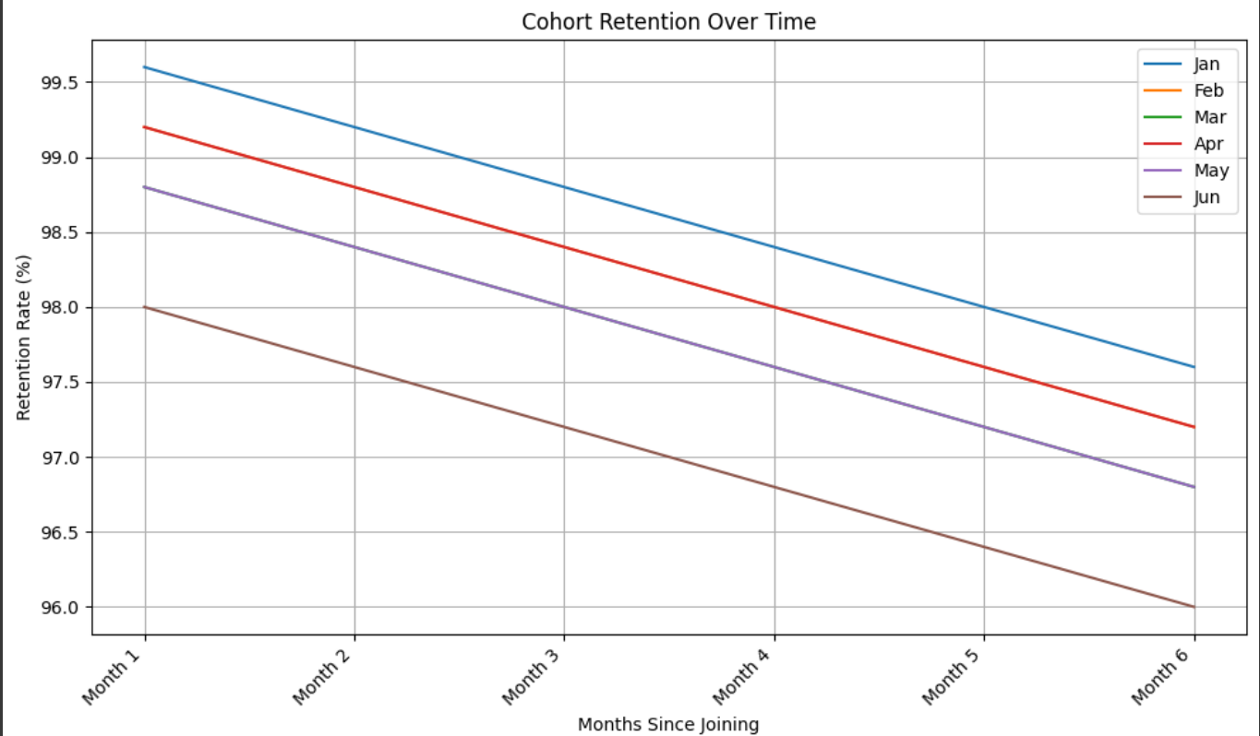

**2️ Heatmap – Visualizing Drop-off Points**🔹 **Interpretation**:

| **Cohort** | **New Users** | **Month 1 Retention %** | **Month 2 Retention %** | **Month 3 Retention %** | **Month 4 Retention %** | **Month 5 Retention %** | **Month 6 Retention %** |
| --- | --- | --- | --- | --- | --- | --- | --- |
| Jan | 25 | 100% | 99.6% | 99.2% | 98.8% | 98.4% | 98% |
| Feb | 25 | 99.2% | 98.8% | 98.4% | 98% | 97.6% |  |
| Mar | 25 | 98.8% | 98.4% | 98% | 97.6% |  |  |
| Apr | 25 | 99.2% | 98.8% | 98.4% |  |  |  |
| May | 25 | 98.8% | 98.4% |  |  |  |  |
| Jun | 25 | 98% |  |  |  |  |  |

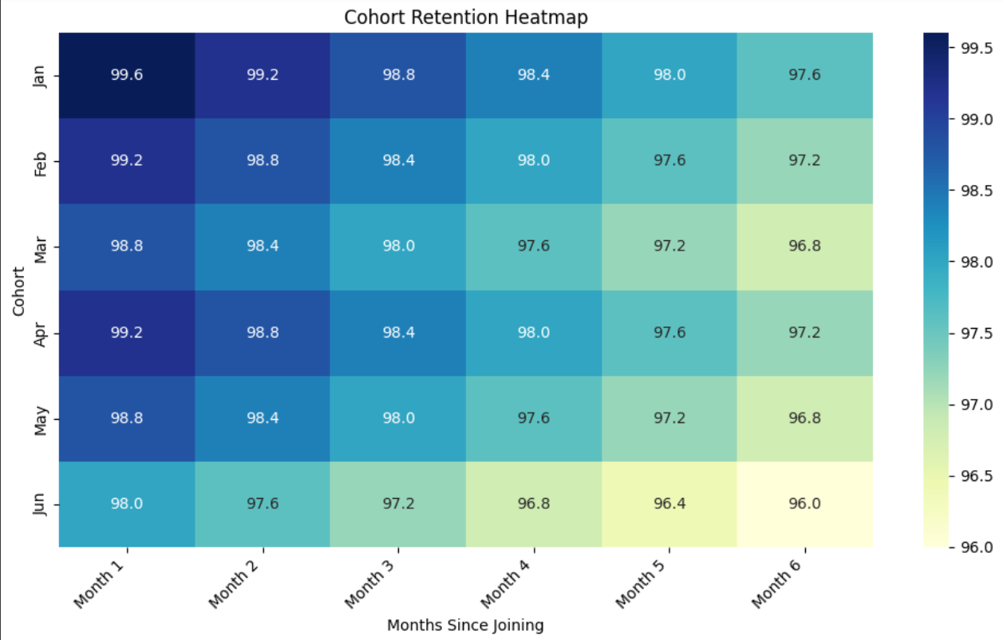

**Step 6: Actionable Insights**

**Overall Observations:**

* **High Retention:** The heatmap shows generally high retention rates across all cohorts, with most values in the 96-99% range. This indicates strong user loyalty and satisfaction with the product.
* **Month 1 is Key:** As expected, there's a slight drop in retention from Month 0 (not shown, assumed to be 100%) to Month 1. This highlights the importance of focusing on user onboarding and initial engagement to maximize retention beyond the first month.
* **Gradual Decline:** Retention gradually decreases over time for all cohorts, which is a natural pattern. However, the rate of decline appears slow and steady, further reinforcing the product's stickiness.
* **Consistency Across Cohorts:** The retention patterns are relatively consistent across different cohorts (Jan, Feb, Mar, Apr, May, Jun). This suggests that the product is maintaining its value proposition and user experience over time.

**Specific Insights:**

* **January Cohort:** Shows the most complete retention trend, declining gradually from 99.6% in Month 1 to 97.6% in Month 6. This cohort can serve as a benchmark for evaluating the performance of newer cohorts.
* **June Cohort:** Naturally, it has the fewest data points. Its Month 1 retention is slightly lower at 98%, but it's too early to tell if this indicates a trend or is just a minor fluctuation.
* **No Dramatic Shifts:** There are no dramatic drops or spikes in retention for any cohort, suggesting consistent user engagement and a lack of major disruptive events or changes to the product during this period.

**Potential Areas for Further Investigation:**

* **Reasons for Month 1 Dip:** While the Month 1 retention is still high, it's worth investigating why there's a slight drop. Are there specific pain points in the initial user experience that can be addressed?
* **Long-Term Trends:** Extending the heatmap with more data for subsequent months will reveal longer-term retention trends and help assess the product's ability to retain users over an extended period.
* **Segmentation:** Analyzing retention by user segments (e.g., demographics, usage patterns, acquisition channels) can reveal more granular insights and identify specific areas for improvement.

**Overall, this heatmap paints a positive picture of user retention. The high and consistent retention rates suggest a valuable product that users are happy with. However, continuous monitoring and analysis are crucial to identify potential issues early and ensure long-term user loyalty.**

**Scenario 2:**

The fintech company is testing two different loan approval notification designs. Version A is a simple approval message, while Version B includes additional loan details (e.g., repayment options, interest rate, and payment reminders). They want to see which design leads to more loan acceptance.

**Question 1:**How would you structure an A/B test to measure the impact of these notification designs on loan acceptance rates?

* **Hint:** Track loan acceptance rates (percentage of users who accept the loan offer), average loan amount, and repayment behaviors after loan acceptance.

**Scenario 2: A/B Testing Loan Approval Notifications**

A fintech company is testing two versions of loan approval notifications:

* **Version A:** A simple approval message.
* **Version B:** A detailed message including loan details like repayment options, interest rates, and payment reminders.

The goal is to determine which version leads to higher loan acceptance rates.

To measure the impact of notification designs on loan acceptance rates, we will conduct an **A/B test** using the following steps:

**1. Define Key Metrics to Measure**

The primary metrics to track include:

* Loan Acceptance Rate
* Loan Acceptance Rate = (Number of loans accepted / Total number of loan offers sent) × 100
* Average Loan Amount (mean value of accepted loans).
* Repayment Behavior (on-time payments, defaults, early repayments).

**2. Randomly Assign Users to Groups**

* **Group A (Control):** Receives **Version A** (simple approval message).
* **Group B (Test):** Receives **Version B** (detailed loan information).
* Ensure users are **randomly assigned** to avoid bias.

**3. Ensure Sufficient Sample Size**

* You can use different methods to find the sample size e.g. **power analysis**.
* Factors to consider:
  + Expected effect size (e.g., a 5%-10% increase in loan acceptance).
  + Confidence level (typically **95%**).
  + Statistical power (typically **80%**).

Example: If the baseline loan acceptance rate is 20%, and we expect Version B to increase it to 22%, we need a large enough sample to detect this difference with statistical significance.

**4. Conduct the A/B Test**

* **Deploy notifications** for a fixed period (e.g., 1 month).
* **Monitor the loan acceptance rate** for both groups.
* **Collect data** on additional metrics:
  + Loan amounts.
  + Repayment behaviors (e.g., missed payments, on-time payments).

**5. Analyze Results**

* Compare **loan acceptance rates** between Group A and Group B.
* Use **statistical tests** to determine if differences are statistically significant.
* Visualize the results using:
  + **Bar charts** for acceptance rates.
  + **Line graphs** to track changes over time.
  + **Cohort analysis** to see if repayment behavior differs between the groups.

**6. Make a Decision**

* If **Version B** significantly improves acceptance rates, consider implementing it.
* If the difference is marginal or if repayment behavior worsens, **reassess the messaging strategy**.

**Question 2:  
Suppose Version B (detailed notification) results in a 10% increase in loan acceptance rates but requires additional resources to implement. How would you evaluate whether the increase in acceptance rates justifies the added complexity?**

**Solution:**

Version B increases loan acceptance rates by **10%**, but it requires additional resources to implement. To decide whether the increase is justified, we conduct a **cost-benefit analysis**.

**1. Calculate the Additional Revenue from Version B**

**Assumptions:**

* **Loan amount per user:** $10,000
* **Interest rate:** 10% annually
* **Loan tenure:** 1 year
* **Users receiving loan offers per month:** 10,000
* **Baseline (Version A) acceptance rate:** 20%
* **Version B acceptance rate:** 22% (**10% relative increase**)

**Revenue Calculation:**

     Revenue per loan:

* Interest Amount = Loan Amount × Interest Rate

                                       = 10,000 x 10% = 1,000

* Incremental loans accepted due to Version B:

                                          (22% - 20%) x 10,000 = 200 additional loans per month

* Incremental revenue per month:

                                           200 x 1,000 = 200,000

* Annual incremental revenue:

                                          200,000 x 12 = 2.4 million

**2. Cost-Benefit Analysis**

**Estimated Costs of Implementing Version B:**

    • Development costs (UI/UX design, engineering updates) = $50,000 (one-time cost)

    • Additional customer support inquiries = Minimal (assumed negligible)

    • Risk of increased defaults = Not measured in this case

**Net Benefit Calculation:**

Net Benefit = Incremental Annual Revenue - Implementation Cost

= 2.4M - 50K = 2.35M

**3. Additional Considerations**

* **Break-even analysis:**
  + Determine the minimum increase in acceptance rate required to offset costs.
* **Long-term impact:**
  + If Version B **improves customer experience**, it may lead to **higher retention**.
  + If it **confuses users**, it could lead to **higher default rates**, offsetting revenue gains.
* **Regulatory and Compliance Checks:**
  + Ensure Version B follows financial regulations for loan disclosures.

**Final Recommendation:**

If **default rates remain stable** and the increase in loan acceptance leads to a significant revenue boost, **Version B should be implemented**. However, the company should continue monitoring long-term repayment behaviors to ensure sustainability.

**Conclusion**

By conducting an A/B test and performing a **cost-benefit analysis**, the company can make a data-driven decision on whether the additional complexity of Version B is worth the increase in loan acceptance.